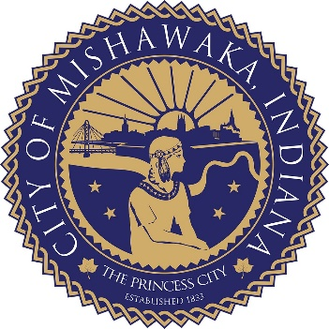
CITY OF MISHAWAKA
MILITARY HOMETOWN HEROES PROGRAM

HONOREE RELEASE FORM

I hereby grant permission to the City of Mishawaka to utilize my name and likeness for the Military Hometown Heroes Program.

Dated this day of , 20 .

Honoree Signature

Page 1 of 1

